**Ready-or-not Tot Project**





Parenting is work. It requires a great deal of time and energy. The demands of caring for a baby keep a parent on duty for 24 hours a day, seven days a week. The ready-or-not tot teaches students how demanding babies can be throughout the day and night. The manikin cries at intervals, requiring action from the student parents in order to quiet the manikin.

Being a parent can be the most rewarding experience of a lifetime. The question at hand is at what point in your life are you ready to become a parent? At what point are you responsible enough? How would having a baby affect your short and long term goals. How does becoming a teen parent alter your opportunities for furthering your education and fulfilling your career dreams? What about your social and emotional life? Would the time commitment involved in caring for a child change your growth and development and affect your friendships? Do you want to be connected to your current partner for life? What does it cost to care for a child? Can you afford this? This parenting simulation project is in addition to our abstinence and sexually transmitted disease unit and will help you to think about these questions.

Each student will be sent home with the simulation tot. The rotations run Monday through Friday and are random. So your child might get the baby for one night on a school night or for the weekend. Students must complete the tending log for a grade. If for some reason your student is unable to take the manikin home they will complete the 5 page paper assignment for their parenting grade. The alternative assignment will only be allowed in extreme circumstances. It is our goal to have every student complete the simulation project.

Students are responsible for the complete cost of the ready-or-not tot and all the baby essentials while they are assigned the project. Therefore, if they lose/break the manikin they will be held responsible. The totally cost of each unit and their accessories is $500.00. Students will pick up their assignment at the end of the day and drop off the manikin at the start of the next school day. Students are responsible for the following items:

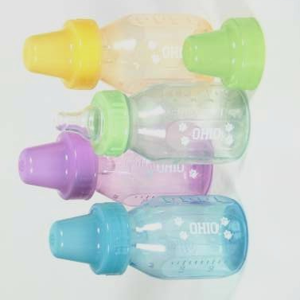

* Ready-or-not tot manikin
* Car seat
* Diaper bag containing
* Bottle, Pacifier & 2 Extra Diapers
* Blanket & Hat
* Change of Clothing & Toy Animal

We are fortunate to have been able to purchase these interactive parenting manikins. With proper care, they should last many years. DO NOT GET THE MANIKIN WET. DO NOT FEED THE MANIKIN. Good luck and we hope this is a valuable learning experience. Please get the attached permission slip signed and return.

**Mrs. Turner & Ms. Feldmann**

**Health Education NTMS**

**Ready-or-NOT Tot**

**Parental Consent Form**

Dear Parent or Guardian,

In order to provide students with a realistic idea of the demands of parenting, your child, will be participating in a parenting simulation project as a part of their health class. This project involves caring for our lifelike, electronic, parenting manikin. The manikin cries periodically throughout the day and night. Your child will be responsible for providing proper care as if this were a real baby. The manikin should be with them at all times, except in emergency situations, when a reliable babysitter can be utilized.

In order for this to be a positive learning experience for your child, we ask your support in helping to monitor student participation while they are at home. Your insistence that they alone care for their manikin will help to impress upon then the tremendous demands that a baby places on a parent’s time, energy and social life.

The Ready-or-Not Tot is an educational tool and not a toy. Your child will be graded on their tending log. The manikin will be set to cry at specific intervals that only the teacher will know. The time interval will then be compared to the student log to see how quickly the student tends to the babies needs. In extreme circumstances an alternative assignment can be issued. Please speak with your students teacher if you believe your child will be needing this alternative assignment. It is our goal to have all students complete this take simulation assignment.

We are very fortunate to have been able to purchase these interactive parenting manikins. They should last many years with the proper care. Manikins cannot get wet or be fed actual food or formula. Your child will be responsible for any damage that occurs as a result of abusive handling or for the loss of the manikin or its accessories. Please see reverse side for a list of accessories and prices.

Thank you for your support during this valuable parenting simulation project. Please sign the below permission slip and have your child return to their teacher.

----------------------------------------------------------------------------------------------------------------------------

I give my child permission to participate in the interactive parenting simulation project. I understand that my child is financially responsible for any damages due to abusive handling or the loss of the simulator or its accessories.

_________________________ __________________________ _____________

Parent Signature Student Name Date